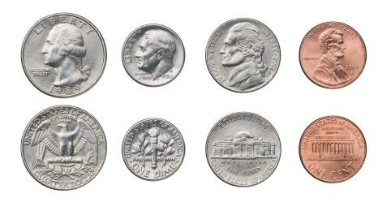

25 ¢ 10¢ 5¢ 1¢

$0.25 $0.10 $0.05 $0.01

